### Plyometric training

Plyometric training, also known as jump or reactive training, is a form of exercise that uses explosive movements, such as bounding, jumping, or forceful upper body movements, to develop muscular power. Employing plyometric training develops efficient control and production of ground reaction forces, which can be used to project the body with greater velocity or speed of movement. The term *reactive training* refers to the reaction stimulus clients encounter during plyometric training, which is the ground surface in this case. Therefore, reactive and plyometric training are used interchangeably throughout this chapter.

It is important for the fitness professional to understand that individual clients must possess adequate core strength, joint stability, and range of motion and have the ability to balance efficiently prior to performing explosive plyometric exercises. Plyometric training may not be an appropriate form of training for individuals with select chronic diseases or other functional limitations. However, the practice of plyometric training is very important considering the numerous injuries that occur as a result of an individual’s inability to control decelerative force and that it is often used in latter stages of physical rehabilitation (Hill & Leiszler, 2011). The purpose of this chapter is to discuss the importance of plyometric training and the physiology and methodology involved in designing and implementing plyometric training into a client’s existing exercise program.

**What Is plyometric training?**

The ability to generate force as quickly as possible is known as rate of force production (Maffiuletti et al., 2016). Success in everyday activities and sport depends on the speed at which muscular force is generated. Research demonstrates that resistance training combined with plyometric exercises significantly increase muscle force production, facilitating increases in strength and power (Mckinlay et al., 2018; Oxfeldt et al., 2019; Peitz et al., 2018).

Plyometric training involves exercises that generate quick, powerful movements involving an explosive concentric muscle contraction preceded by an eccentric muscle action (Slimani et al., 2016). In other words, there is a “cocking” or loading phase described as an eccentric muscle action that dampens or slows the downward movement of the body (deceleration) followed immediately by an explosive concentric muscle contraction (Slimani et al., 2016).

These types of explosive muscular contractions can be seen in practical instances, such as rebounding a basketball. Trained basketball players prepare to jump up for a loose ball by lowering their body slightly by flexing at the ankles, knees, and hips; this is eccentric loading. Players may even drop their arms to assist in takeoff. At a fairly shallow point, players will reverse this downward motion and rapidly project themselves up from the ground extending their ankles, knees, hips, and arms upward, which is the concentric contraction. The overall height of their jump is determined by their vertical velocity, or how fast they leave the ground.

This is the essence of a plyometric exercise and uses a characteristic of muscle known as the stretch-shortening cycle. The stretch-shortening cycle improves the elastic properties of connective tissue and muscle fibers by enhancing stored elastic energy through the eccentric phase and releasing it during the concentric phase to increase force production. (Slimani et al., 2016). In fact, the integrated performance paradigm states that to move with precision, forces must be eccentrically loaded, isometrically stabilized, and then unloaded or concentrically accelerated (Figure 18-1).

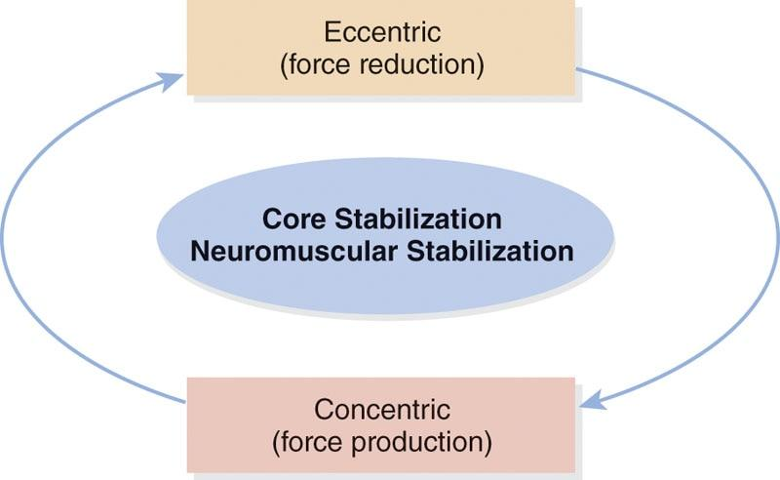

**Figure 18-1** Integrated performance paradigm

**Three phases of plyometric exercise**

There are three distinct phases of the stretch-shortening cycle involved in a plyometric exercise: the eccentric or loading phase, the amortization phase or transition phase, and the concentric or unloading phase (Chmielewski et al., 2006).

The eccentric phase

The first phase of a plyometric movement can be classified as the eccentric phase (deceleration), which describes the preloading or stretching of the agonist muscle. During the eccentric phase, elastic energy is stored, and muscle spindles are stimulated, which sends signals to the central nervous system (Davies et al., 2015; Slimani et al., 2016).

Potential energy is stored in the elastic components of the muscle during this loading phase much like stretching a rubber band. This eccentric phase is predicated on three stretch variables: magnitude of the stretch, rate of the stretch, and duration of the stretch (Davies et al., 2015). Any manipulation of these key variables can enhance the amount of energy stored during the eccentric prestretch action.

The amortization phase

The next phase is known as the amortization phase, also referred to as the transition period or phase, which represents the time between the eccentric phase and the initiation of the concentric contraction (discussed next). In other words, the amortization phase is the period of time from which the eccentric phase ends to the time when the concentric muscle contraction begins (Slimani et al., 2016). The amortization phase is also referred to as the electromechanical delay, which describes that space in time during which the muscle must switch from overcoming force to imparting force in the intended direction (Davies et al., 2015). This phase is critical to plyometric performance, because the shorter the amortization phase is, the more effective and powerful the subsequent plyometric movement will be, as the stored elastic energy is used efficiently in the transition. If the amortization phase is prolonged, the stored elastic energy is dissipated as heat, and the stretch reflex is not fully used, which results in significantly less concentric force output (Davies et al., 2015). One of the primary objectives of plyometric training is to reduce the time in the amortization phase. Therefore, a rapid switch from an eccentric loading phase to a concentric contraction leads to a more powerful response (Davies et al., 2015; Slimani et al., 2016).

The concentric phase

The final phase is the concentric phase, which represents the body’s response to the events that occurred during the eccentric and amortization phases. The concentric phase uses the stored elastic energy from the eccentric phase to either enhance muscle force production or dissipate the energy as heat. For example, during a half movement in a basketball jump shot, as soon as the upward movement begins, the concentric phase has initiated, and the amortization phase has ended. Together, the stretch-shortening cycle describes an eccentric phase in which the muscle is stretched, followed by an amortization phase where the muscle is in a stabilizing, isometric transitional period, which leads to a concentric phase that uses the stored energy in the muscle to deliver an explosive action (Table 18-1) (Oxfeldt et al., 2019; Slimani et al., 2016).

TABLE 18-1 Components of the Stretch-Shortening Cycle

| **Phase** | **Physiological Event** | **Action** |
| --- | --- | --- |
| Eccentric | Stored elastic energy; stimulation of muscle spindles, signal sent to spinal cord | Stretch of agonist muscle |
| Amortization | Nerves meet synapse in spinal cord, signal sent to stretched muscle | Time between the eccentric and concentric phases |
| Concentric | Elastic energy release, enhanced muscle force production | Shortening of agonist muscle |

HELPFUL HINT

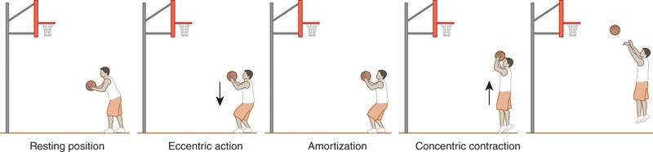

To better understand the stretch-shortening cycle, imagine holding a rubber band. To shoot that rubber band, the first step is to stretch it. Stretching the rubber band creates stored elastic energy that is waiting to be released. The next step is to release the rubber band, which uses the stored elastic energy to propel the rubber band through the air.

Human muscles work in a similar fashion. To jump upwards with maximal velocity, the first action is to quickly perform a shallow squat—an eccentric action. Performing the shallow squat stretches the gluteal complex, quadriceps, and calves. Consequently, these muscles are now storing elastic energy that is waiting to be released. Now, with the stored elastic energy, the jump will be more forceful—a concentric contraction.

**Importance of plyometric training**

Plyometric exercises increase rate of force production (power) and motor unit recruitment (Ebben et al., 2008, 2011). These training exercises are a progression that can be incorporated once a client has achieved an overall strength base, proper core stability, and balance capabilities. Adequate isometric stabilization strength that is developed through core, balance, and resistance exercises decreases the time between the eccentric muscle action and concentric contraction, resulting in shorter ground contact times. This may result in a decrease of both tissue overload and potential injury when performing plyometric training (DiStefano et al., 2010, 2016).

Many movement patterns that occur during functional activities involve a series of repetitive stretch-shortening cycles. Stretch-shortening cycles require the neuromuscular system to react quickly and efficiently after an eccentric muscle action to produce a concentric contraction and impart the necessary force (or acceleration) in the appropriate direction. Therefore, improving functional movements, such as cutting or change of direction, may require exercise routines that emphasize plyometric training (Asadi et al., 2016).

Plyometric training provides the ability to train specific movement patterns in a biomechanically correct manner at a more functionally appropriate speed. This provides strengthening of the muscles and connective tissue to meet the demands of everyday activities and sport (Cherni et al., 2019; Hirayama et al., 2017). The ultimate goal of plyometric training is to maximize function as described by the integrated performance paradigm (Davies et al., 2015). This also results in increased speed of movement for the individual.

The speed of muscular exertion is limited by neuromuscular coordination. Plyometric training improves neuromuscular efficiency and improves the range of speed set by the central nervous system (Davies et al., 2015; Silva et al., 2019). Optimal reactive performance of any activity depends on the speed at which muscular forces can be generated.

Plyometric training is often perceived by many to be too dangerous, potentially increasing the risk of injury. However, plyometric training has a systematic progression sequence that allows a client to begin with less demanding exercises and progress to more demanding exercises as they adapt.

This is no different than any other form of training. If exercises that are too advanced for the client are assigned to their exercise plan, they will not have the ability to perform them correctly and they will compensate. This may lead to faulty movement patterns and increased risk of injury. When placed within a well-designed programming scheme with proper progressions, plyometric training can be a vital component to achieving optimal performance of any activity at any level of ability.

For example, a 65-year-old woman and a 25-year-old male professional athlete may not both need to train for maximal strength. However, they do need stabilization, strength, and endurance as well as the ability to produce force quickly to perform daily activities efficiently. Therefore, it is imperative that both can react and produce sufficient force: for the 65-year-woman to avoid a fall or for the 25-year-old athlete to avoid an opponent. Plyometric exercises are performed with a faster tempo, similar to movements seen in daily life or sport-related activities.

STRETCH YOUR KNOWLEDGE

Evidence to Support the Use of Plyometric Training for Injury Prevention and Performance Enhancement

* Enginsu et al. (2014) examined 36 female volleyball players who carried out a plyometric training for 12 weeks and a control group that carried out no physical training. After 12 weeks, only the plyometric training group significantly improved lower limb movement patterns. It was concluded that plyometric training improves lower limb kinematics and functional performance, suggesting the incorporation of these exercises in preventive programs for anterior cruciate ligament injuries.
* Franchi et al. (2019) concluded that plyometric exercise is an effective exercise method in counteracting the functional effects of sarcopenia (loss of muscle tissue). A training period of only 6 weeks for both young and older individuals achieved similar increases in muscle size and power through plyometric exercise.
* Ozbar (2015) examined 10-week plyometric training in elite female soccer players. Twenty adult players were divided into a plyometric group and a control group. Both groups performed technical and tactical training and matches together. It was found that sprint, counter-movement jump, standing broad jump, peak power, and kicking speed test values were all significantly improved in the plyometric group versus the control group. The results indicated that plyometrics can be useful to strength and conditioning coaches for improving their athlete’s power.
* Vetrovsky et al. (2019) performed a systematic review of plyometric training and its impact on physical function for older adults. Eighteen papers were included in the review, and the authors concluded that plyometric training is a feasible and safe training option for older adults to improve performance, function, and health-related outcomes.

Key Takeaways

* Plyometric training can reduce the risk of injury in competitive athletes.
* Plyometric training increases muscle size and limits the effects of sarcopenia.
* Plyometric training increases muscular power and athleticism.
* Plyometric training is a safe option for older adults to improve function.

**Guidelines for plyometric training**

Plyometric exercises can be an important component of an exercise or sports performance training program to enhance an individual’s movement quality, landing mechanics, and power development. However, plyometric training exercises must be implemented in a systematic and progressive fashion to ensure safety and minimize the chances of injury.

A thorough analysis of a client’s training history, age, and injury history may help distinguish clients who may or may not be prepared for plyometric training.

Assessing movement quality using movement assessments—as discussed in Chapter 12—is also a useful screening tool. To enhance performance while reducing the likelihood of injury, clients must recognize the importance of quality and proper plyometric technique while acquiring adequate base levels of strength and motor control. While all exercise includes some risk, the explosive actions of plyometrics suggest that Certified Personal Trainers should take a measured and progressive approach when using it with athletes and clients (Davies et al., 2015).

**Designing a plyometric training program**

A client must exhibit basic levels of total body strength, core strength, and balance before progressing into plyometric training. Fitness professionals must follow specific program guidelines, proper exercise selection criteria, and detailed program variables, such as intensity, volume, frequency, and progressions. Moreover, plyometric training should only be performed by individuals wearing supportive shoes and on a proper training surface, such as a grass field, basketball court, or tartan track. The training surface can have a profound effect on exercise performance when performing plyometric drills (Ramírez-Campillo et al., 2013).

When designing effective plyometric programs, it is helpful to remember many key concepts. First, plyometric exercises should progress from simple, to intermediate, to advanced movements and from low intensity to medium intensity to high intensity. As a general rule, clients should practice plyometric skills comprising dual-foot drills before progressing to single-foot drills.

Intensity

Plyometric intensity describes the distance covered and the amount of effort or stress applied by the muscles, connective tissue, and joints during plyometric drills (Davies et al., 2015; Oxfeldt et al., 2019). Intensity should be programmed based on the client’s ability to execute the exercise while maintaining adequate training technique. If technique is lost, the intensity should be lowered until proper technique is achieved. It is always better to start off conservatively, because the fitness professional can always increase the intensity of the exercises once the client masters the movement pattern. Moreover, it is important for clients to feel confident and display adequate movement competency during their exercise routine. If exercises are too difficult, clients may express feelings of shame, and consequently, their adherence to the exercise program may become compromised.

Volume

Plyometric volume is expressed as the number of foot contacts, throws, or catches. An example would be the completion of three sets of five squat jumps, equating to a volume of 15 total squat jumps (3 × 5). The volume in plyometric training is determined by the choice of exercise and intensity of movement. As with other forms of exercise training, an increase in intensity is often paired with a decrease in training volume.

Training frequency and recovery

Training frequency is determined by the client’s fitness level, current training program, training history, injury history, and training goals. A general recommendation is to allow at least 1 day between intense plyometric training sessions. At least 48 to 72 hours between sessions is the recommended guideline when implementing plyometrics for novice individuals. Research suggests that recovery between workouts must be sufficient to prevent overtraining and injury (Davies et al., 2015). Most apparently healthy clients will be able to perform one to three plyometric training sessions per week.

Essentially, the higher intensity the drill, the more rest is needed between sets. By not providing a sufficient recovery period between sets, adequate recovery may not occur and thus will negate potential benefits. As a general rule, recovery times of 60 to 120 seconds between drills should be sufficient for full recovery, but this is strictly determined by the client’s fitness level. See Table 18-2 for a list of plyometric training guidelines.

TABLE 18-2 Plyometric Training Guidelines

| **Plyometric Training Variables** | |
| --- | --- |
| Planes of motion   1. Sagittal 2. Frontal 3. Transverse | Volume   * Sets   + Low   + Moderate   + High * Repetitions   + Low   + Moderate   + High |
| Speed of motion   1. Slow 2. Medium 3. Fast 4. Explosive | Safety   * Performed with supportive shoes * Performed on a proper training surface   + Grass field   + Basketball court   + Tartan track surface   + Rubber track surface * Performed with proper supervision |
| Progressive   1. Easy to hard 2. Low to high amplitude 3. Simple to complex 4. Known to unknown 5. Body weight to loaded 6. Activity specific | Recovery   * Allow at least 24 hours between plyometric training sessions   + 48–72 hours for new or deconditioned clients |

**Plyometric training progressions**

When introducing plyometric exercises, especially to new or beginner clients, the movements should initially involve small jumps (lower amplitude) to best learn the movement pattern. They are designed to establish optimal landing mechanics, postural alignment, and eccentric strength (ability to decelerate). When an individual lands during these exercises, they should hold the landing position (or stabilize) for 3–5 seconds. During this time, individuals should make any adjustments necessary to correct faulty postures before performing the next jump. Example exercises using this protocol include (but are not limited to) the following:

* Squat jump with stabilization
* Box jump-up with stabilization
* Box jump-down with stabilization
* Multiplanar jump with stabilization.

The next progression involves jumps with more amplitude and dynamic motion. The speed of the jumps is also progressed. These exercises are intended to improve dynamic joint stabilization, eccentric strength, rate of force production, and coordination of the entire human body. These exercises are performed in a repetitive fashion, spending a relatively short amount of time on the ground before repeating the drill. In other words, the client will no longer hold the landing position for 3–5 seconds but instead initiate another jump upon landing using a moderate (repeating) tempo. Some example exercises using this protocol include (but are not limited to) the following:

* Squat jump
* Tuck jump
* Butt kick
* Power step-up.

The last progression includes exercises that involve explosive, powerful movements. These exercises are designed to further improve rate of force production, eccentric strength, and reactive joint stabilization. These exercises are performed as fast and as explosively as possible. Some example exercises using this protocol include (but are not limited to) the following:

* Ice skaters (also known as skater jumps)
* Single-leg power step-up
* Proprioceptive plyometrics
* Depth jump.

**Plyometric Exercises**

Squat Jump with Stabilization

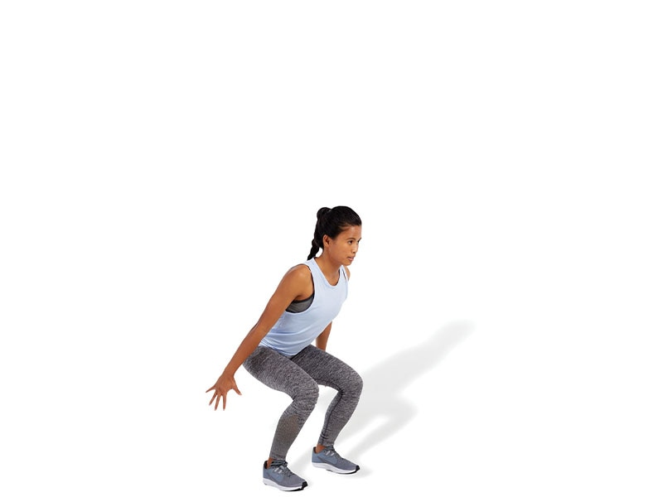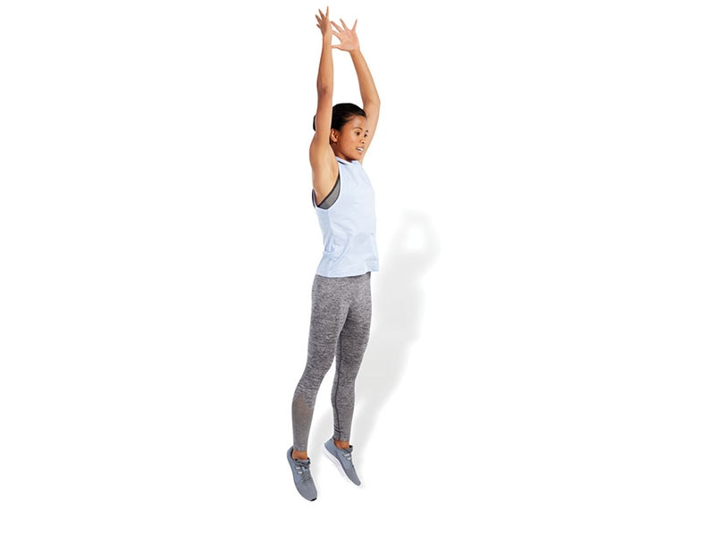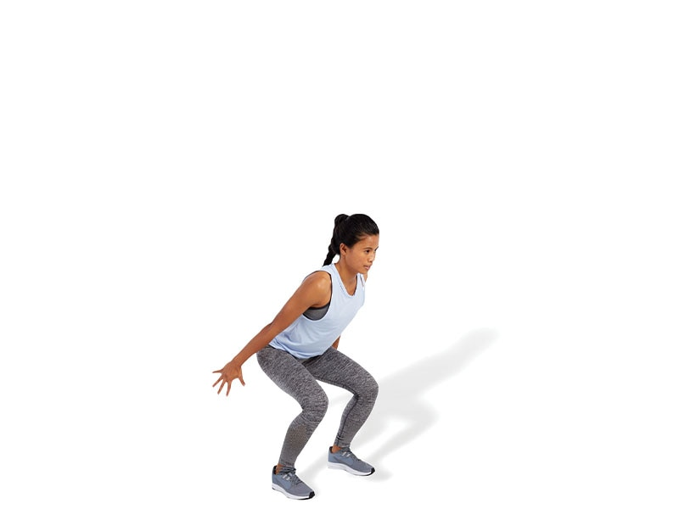

TECHNIQUE

Make sure the knees always stay in line with the toes, both before jumping and on landing. Do not allow feet to excessively turn outward or knees to cave inward.

Multiplanar Box Jump-Up with Stabilization

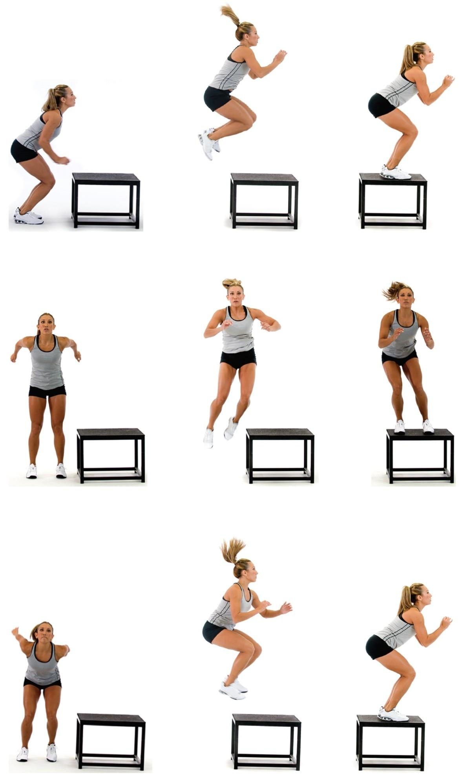

SAFETY

Select a box height that is consistent with the physical capabilities of the client performing the exercise.

Multiplanar Box Jump-Down with Stabilization

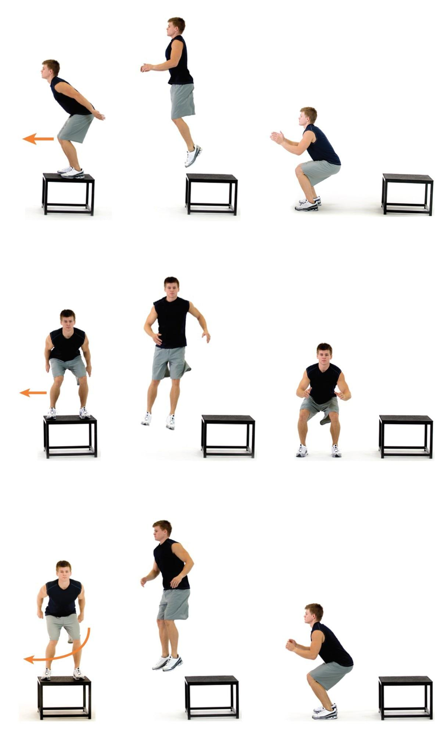

TECHNIQUE

Make sure the client steps off and drops from the prescribed height when initially attempting this exercise. Jumping from the box presents different variables and levels of load or intensity of the exercise and can be used as a progression. Make sure the client lands softly and quietly on the ground to ensure proper force transmission through the tissues of the body. Do not let the client land with legs straight.

Multiplanar Jump with Stabilization

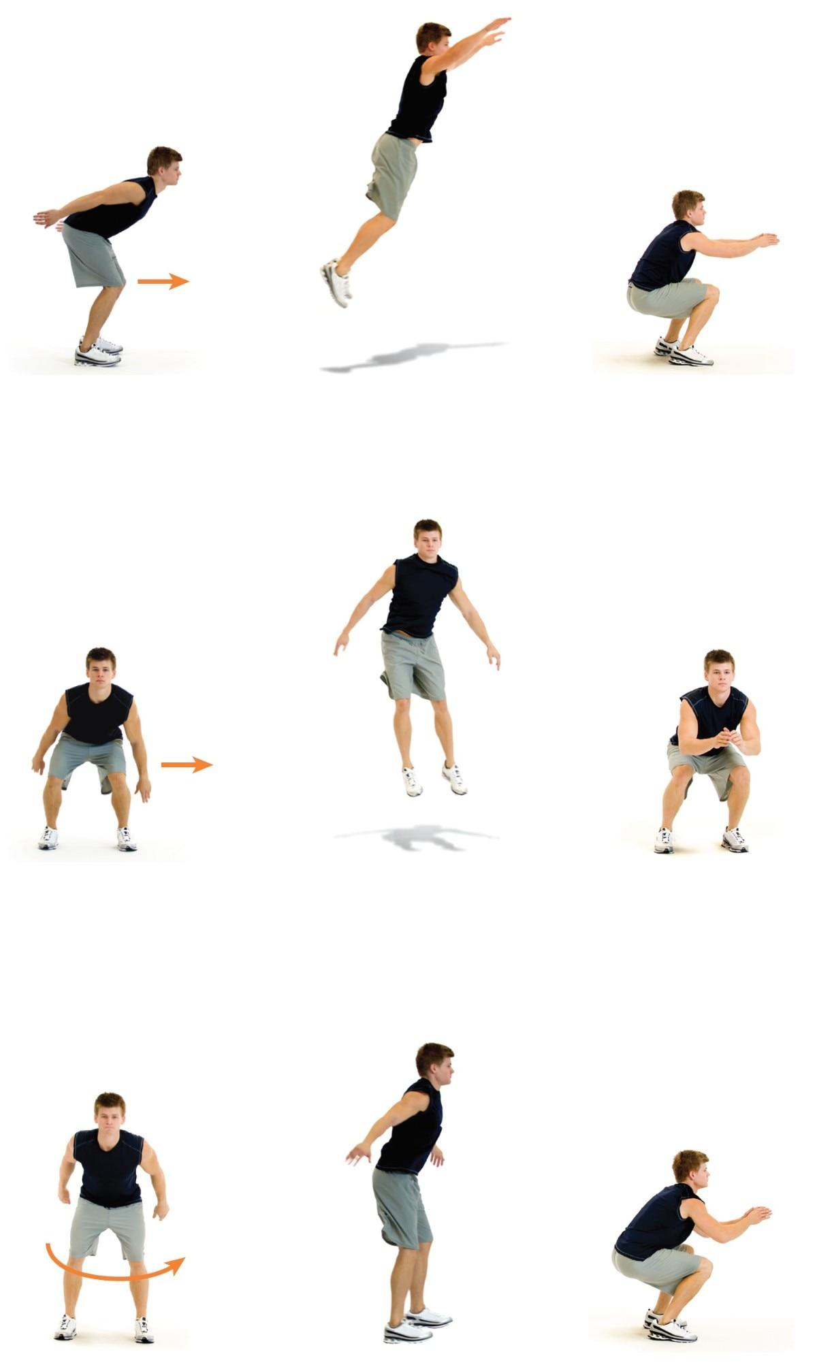

SAFETY

Injuries often occur when rotating or moving laterally, which is why it is important for clients to learn how to accelerate, decelerate, and stabilize in all planes of motion.

Squat Jump

 

TECHNIQUE

Make sure to land with the ankles, knees, and hips flexed and pointed straight ahead, which becomes the takeoff position as well. This will ensure optimal joint mechanics and muscle recruitment. Perform the exercise with a repetitive (medium) tempo.

Lunge Jump

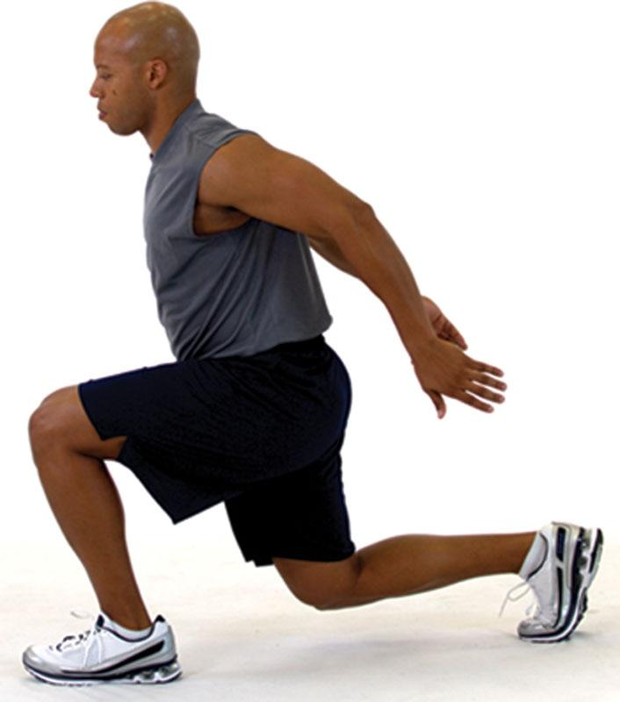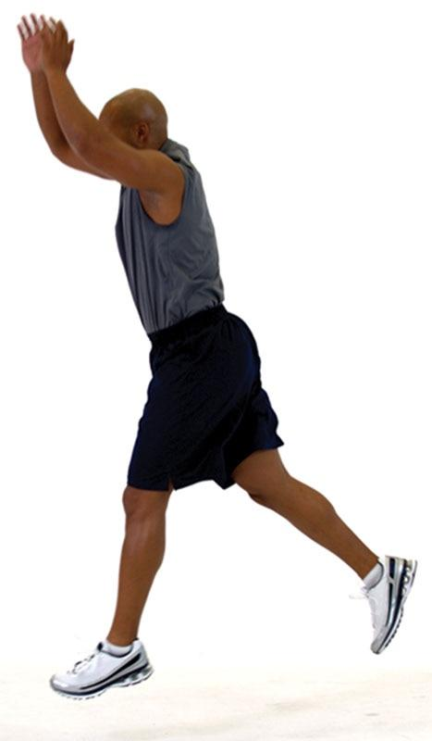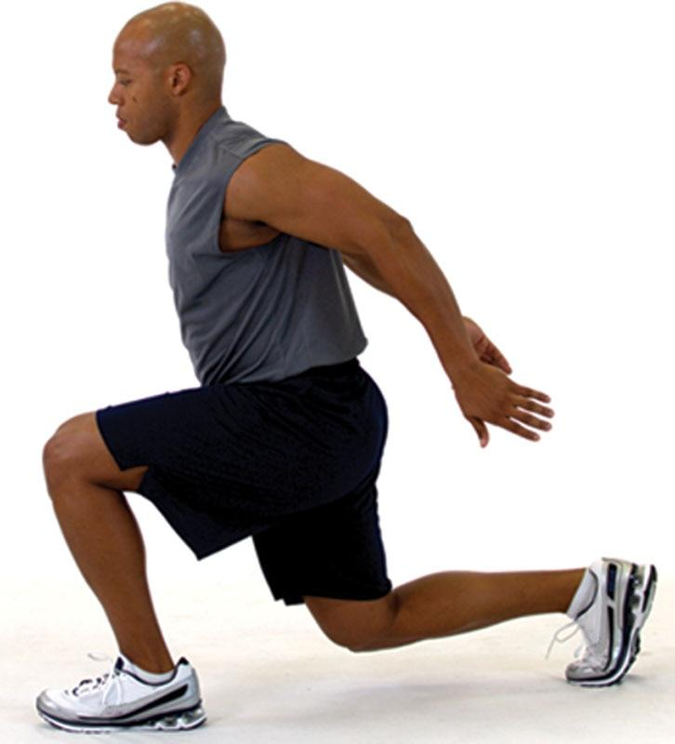

TECHNIQUE

Make sure to keep the front foot pointed straight ahead during takeoff and landing. Do not allow the front foot to externally or internally rotate. Also, keep the front knee pointed straight. Do not allow the front knee to cave inward during the landing, as this can cause stress to the connective tissue within the knee.

Tuck Jump

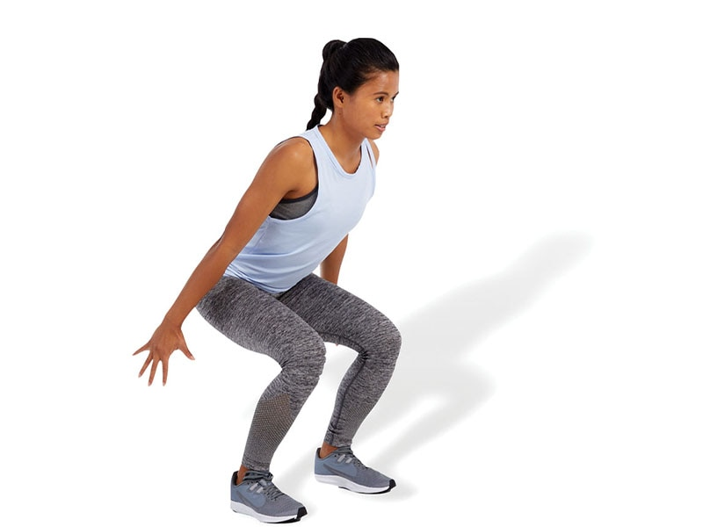 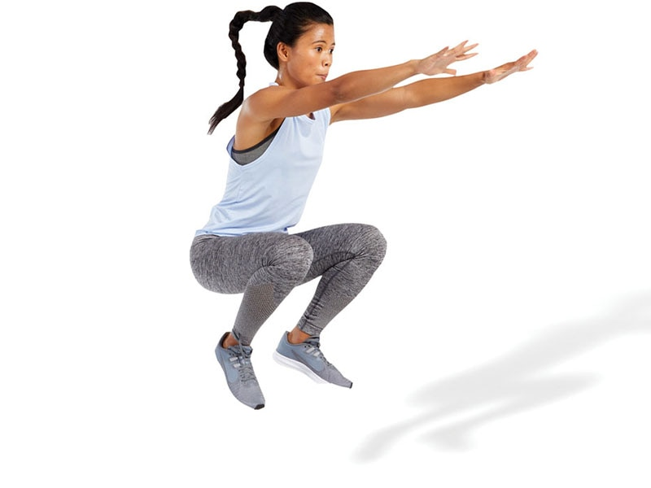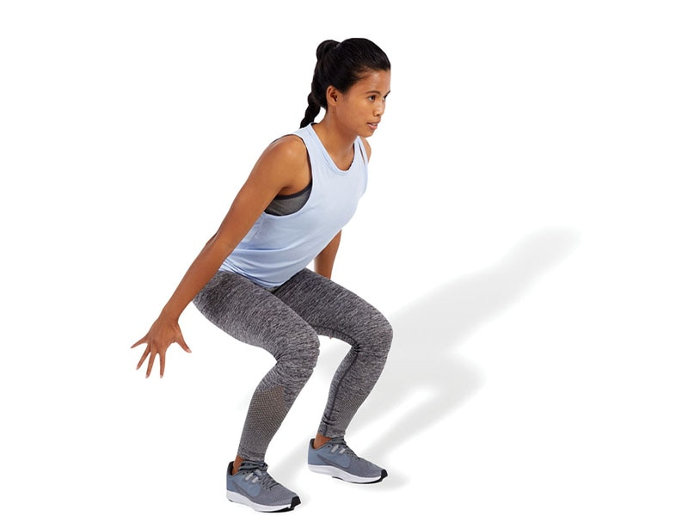

SAFETY

Now that the exercises are becoming more dynamic, proper alignment and landing mechanics will be even more important to maximize force production and prevent injury.

Butt Kick

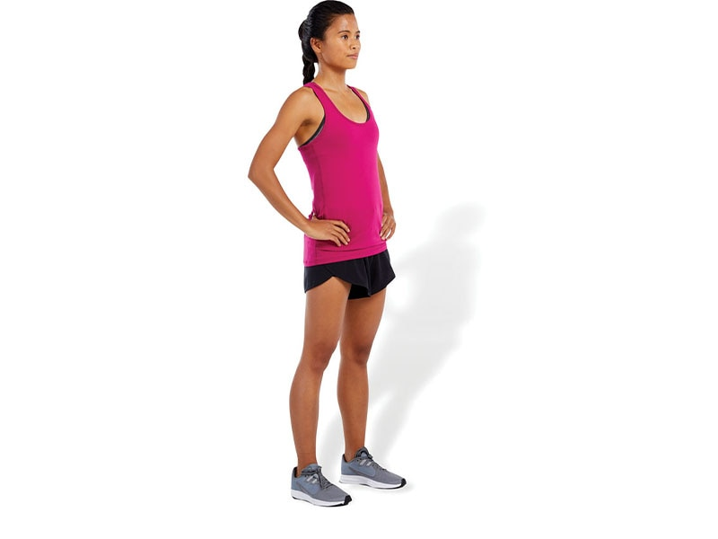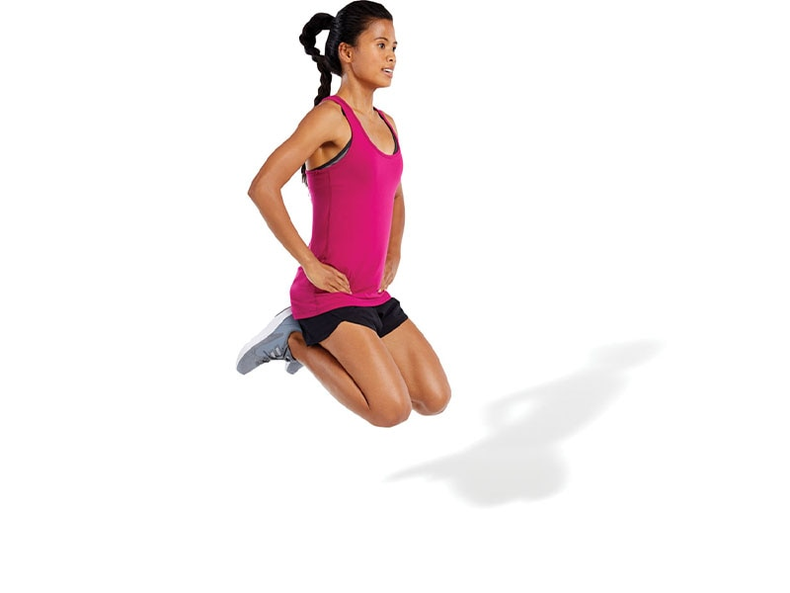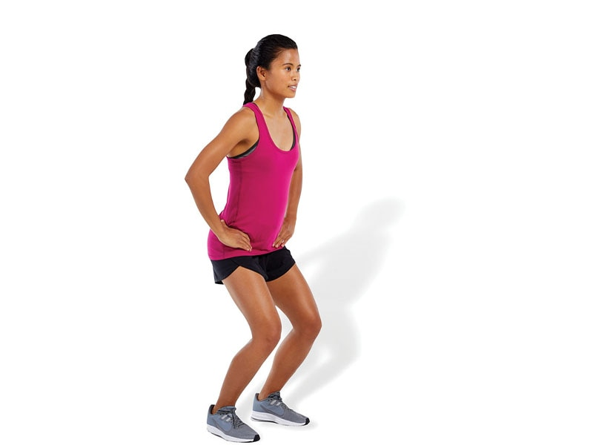

SAFETY

It is important that the client has ample amounts of flexibility of the quadriceps to ensure proper execution. Tight quadriceps may cause a client to arch their lower back when bringing their heels toward the gluteal muscles.

Repeat Box Jumps

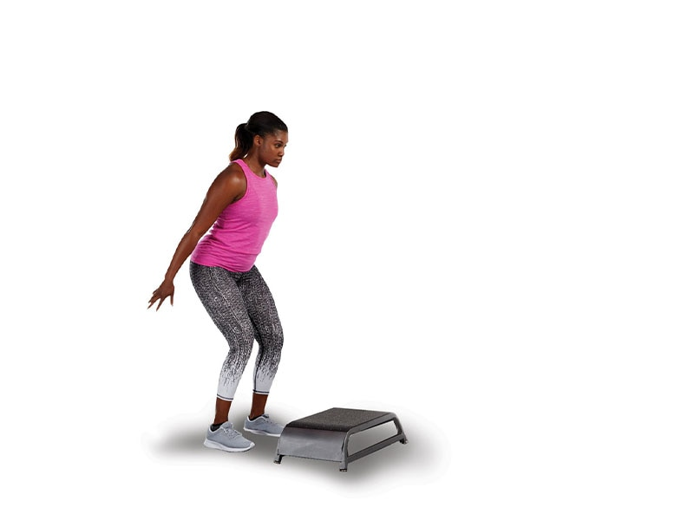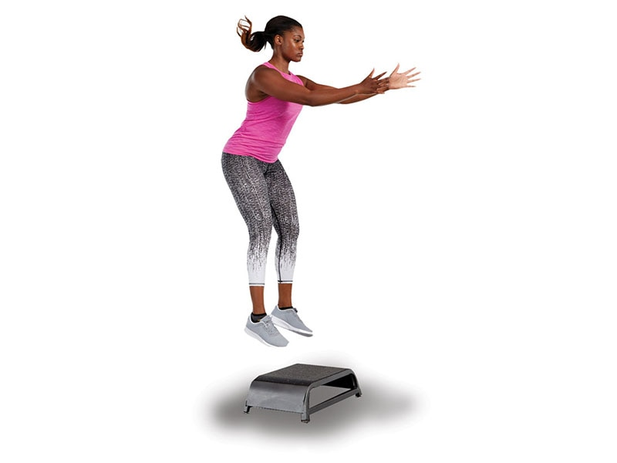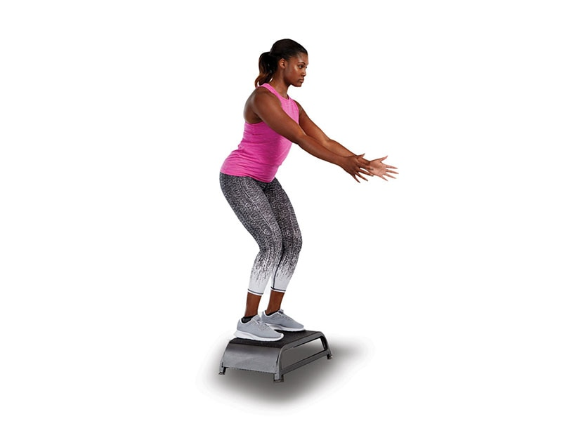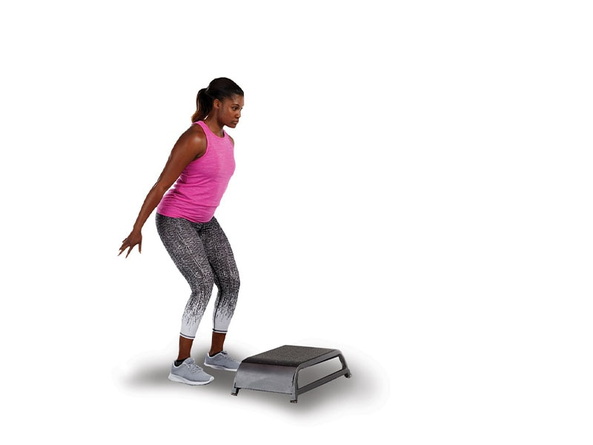

SAFETY

Choose a box height that is appropriate for your client. Tripping on the box is a potential hazard.

Power Step-Up

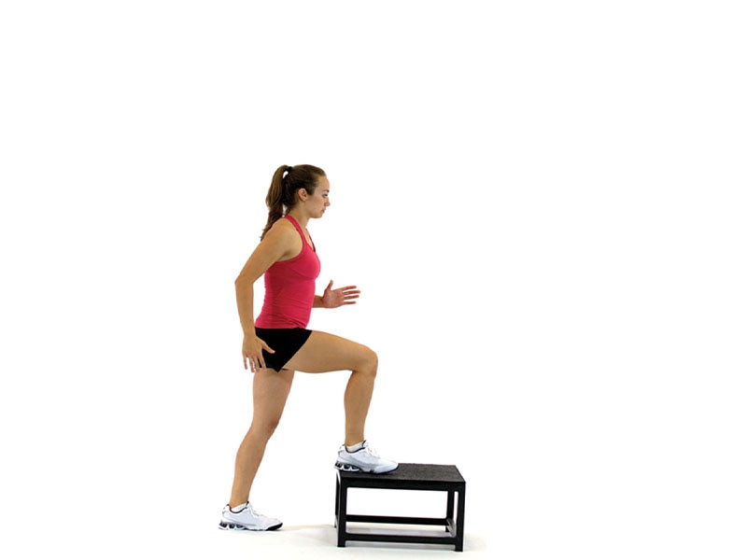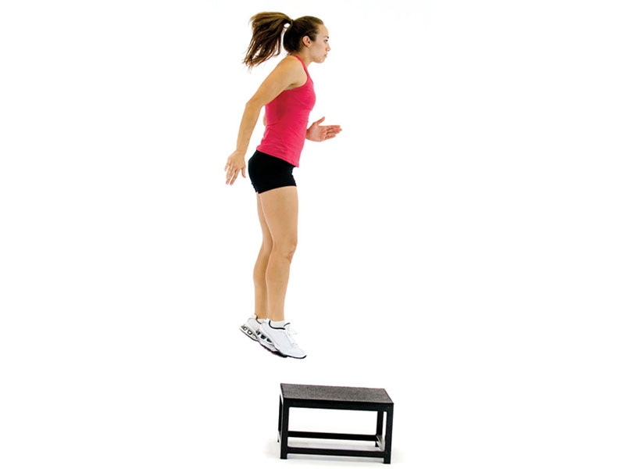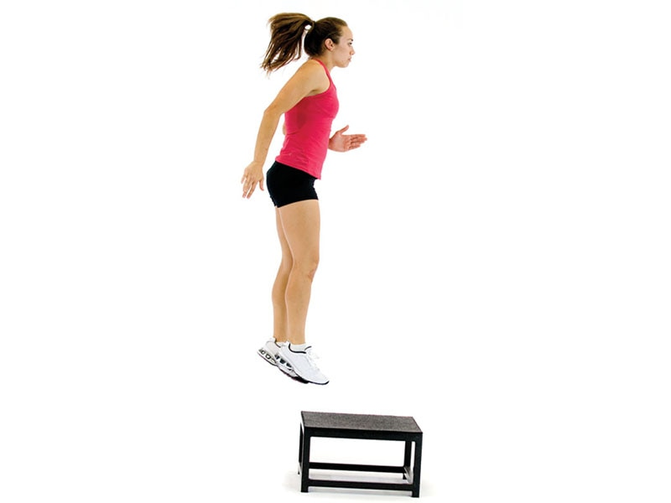

TECHNIQUE

Make sure the knees always stay in line with the toes throughout the jumping phases of takeoff and landing.

Ice Skaters (aka Skater Jumps)

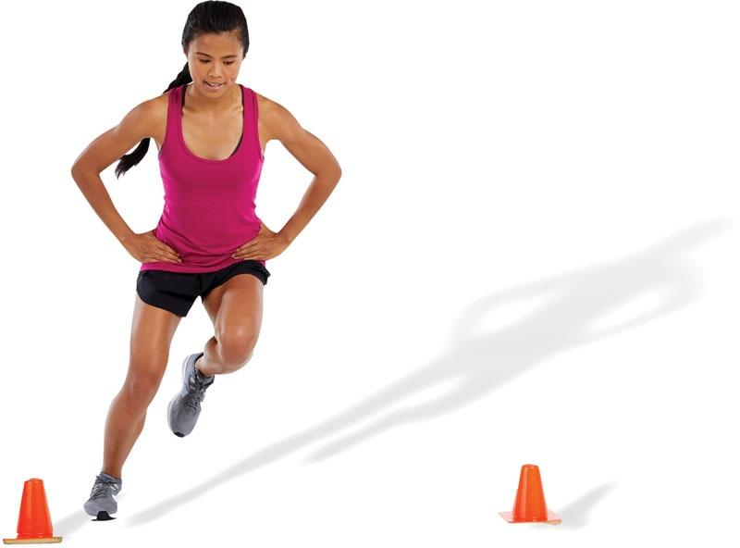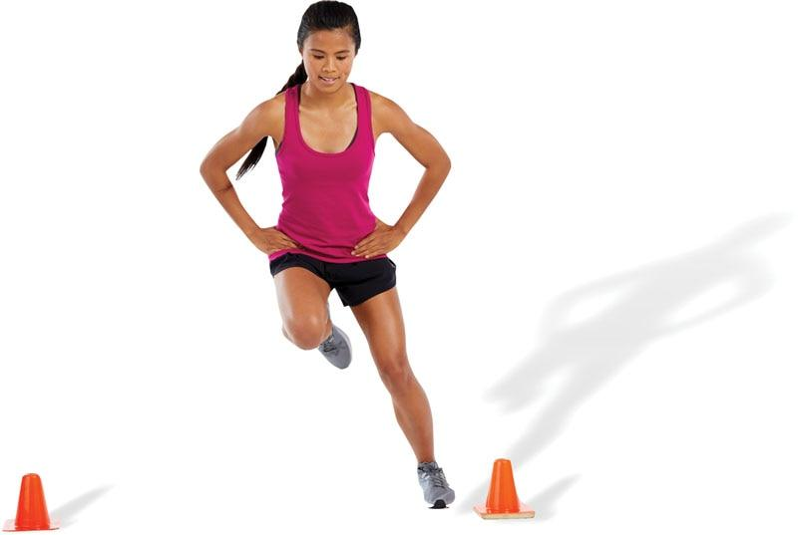

TECHNIQUE

The client can start by hopping side to side from one foot to the other as fast as possible and then progress by adding a reach with the opposite hand to make it more integrated (skating action).

Single-Leg Power Step-Up

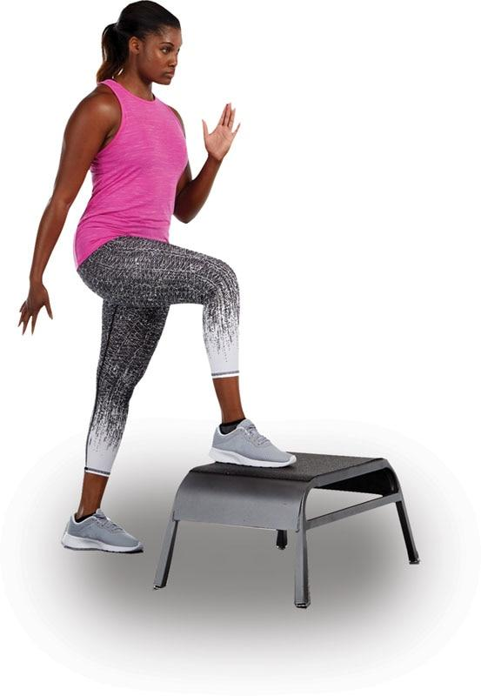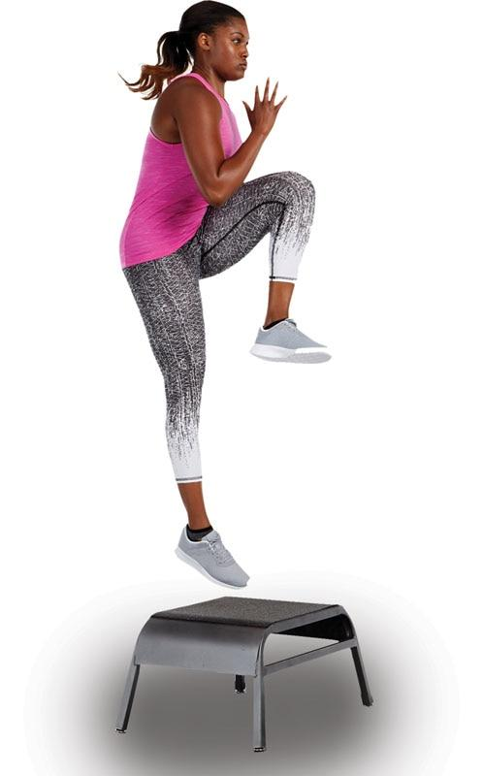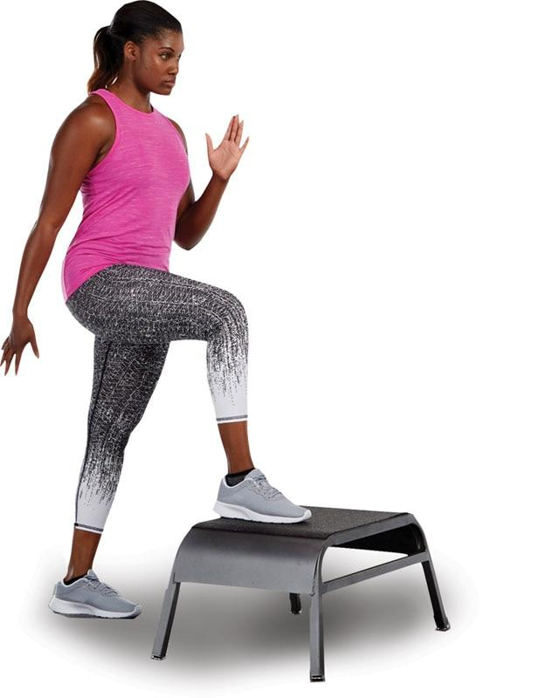

SAFETY

Clients must be made aware that one foot will land on the box and the other will continue to the ground so that the legs will be offset during the landing phase. Therefore, they must be mentally prepared to absorb the landing in this unique position.

Proprioceptive Plyometrics

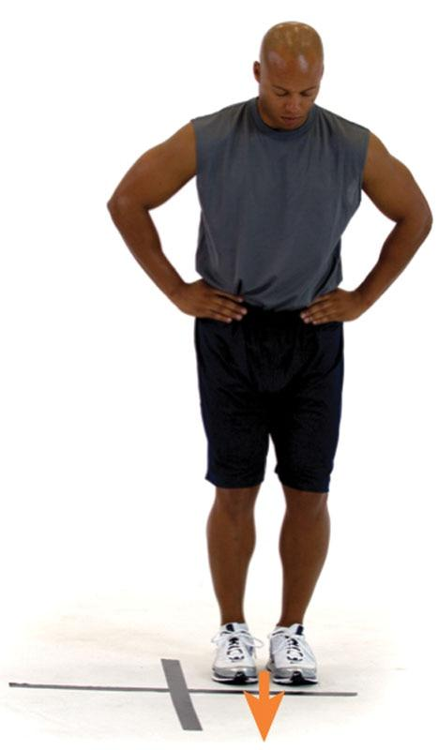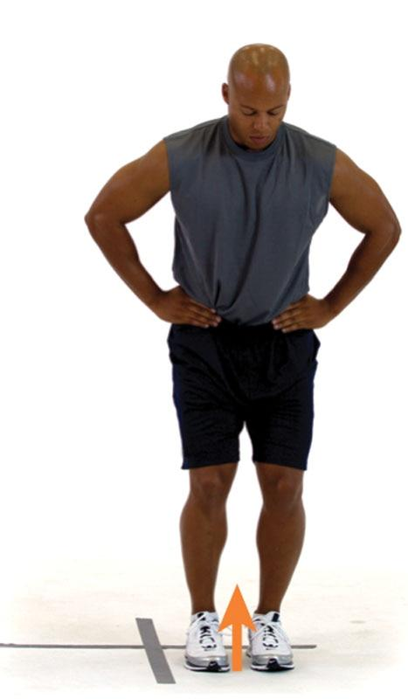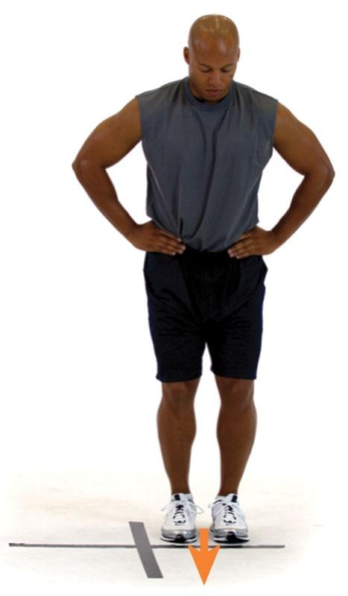

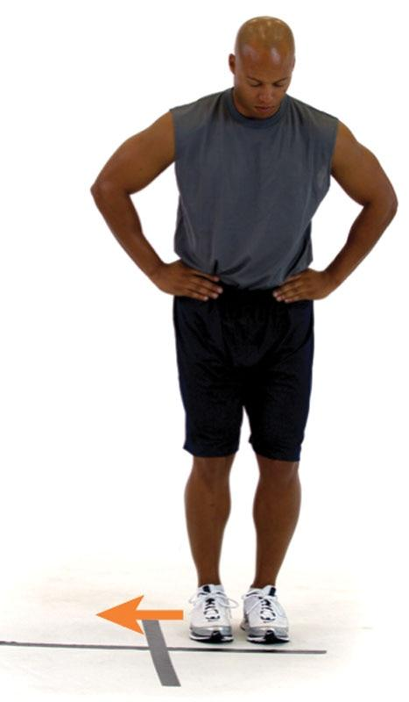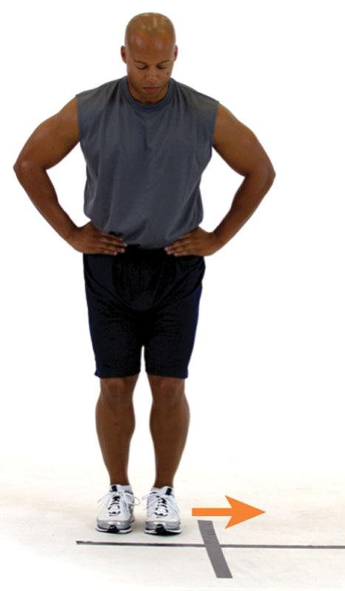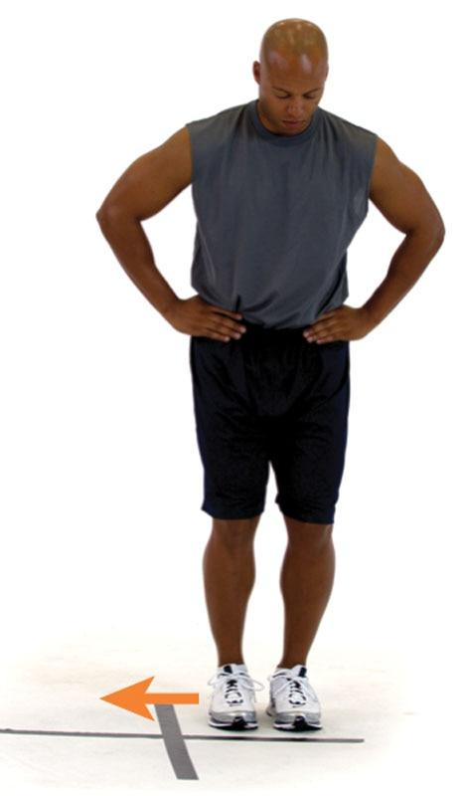

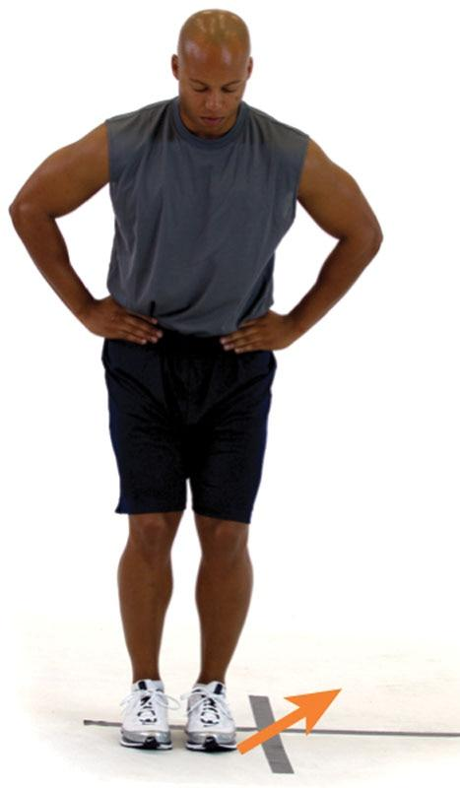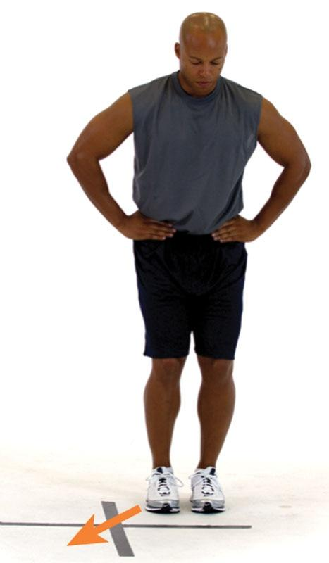

TECHNIQUE

This exercise can be performed with cones or hurdles to increase the intensity of the exercise. If cones or hurdles are not available, the fitness professional can also place tape on the floor in the form of an X and perform the exercise by jumping in different quadrants.

Depth Jump

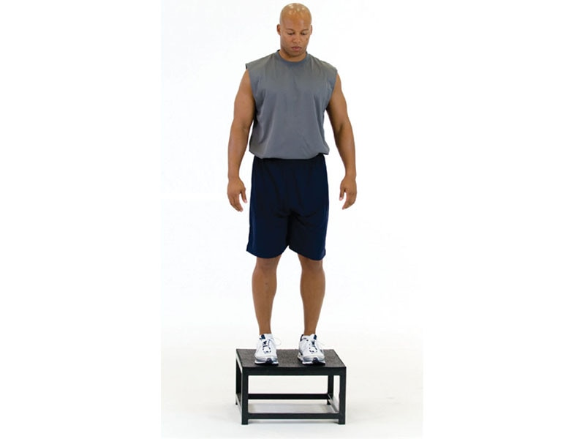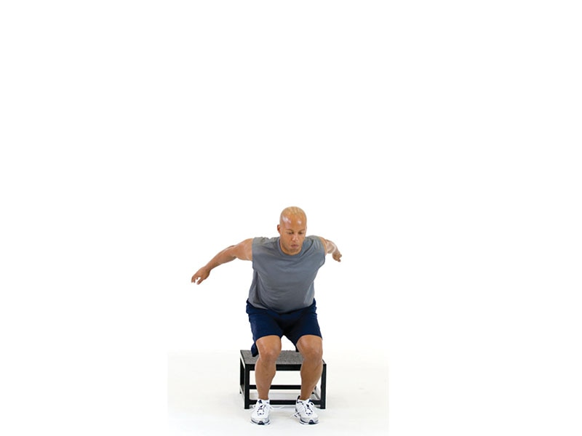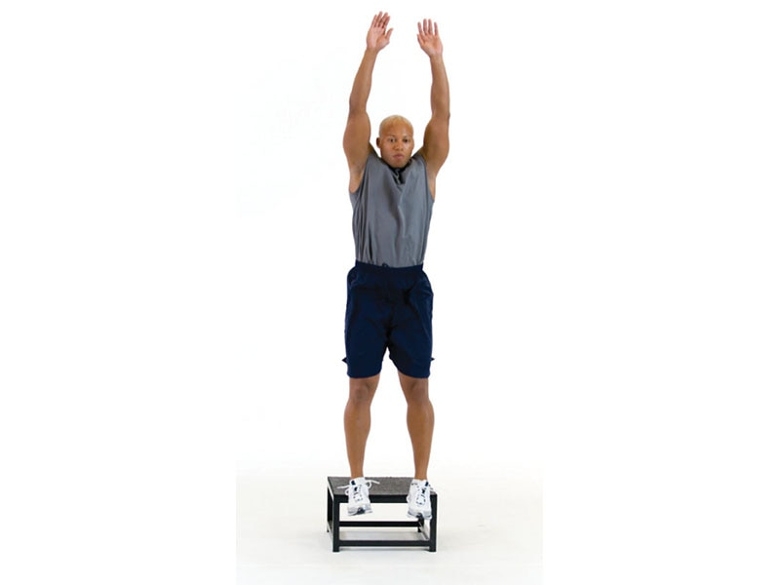

TECHNIQUE

Land from the box softly with both knees pointed straight ahead before initiating the jump from the ground. The depth jump is an advanced plyometric exercise that requires precise technique.

Plyometric Push-Up

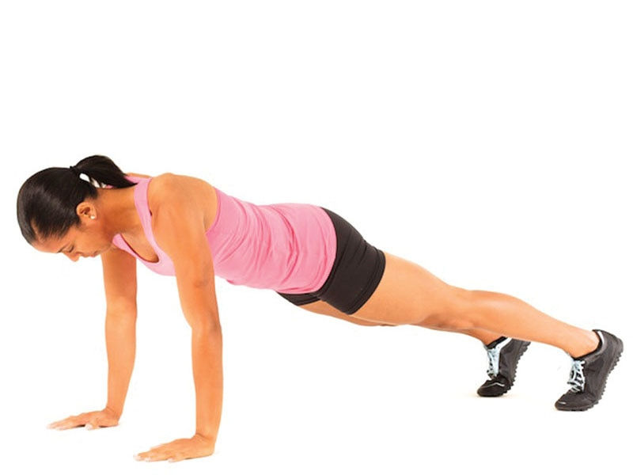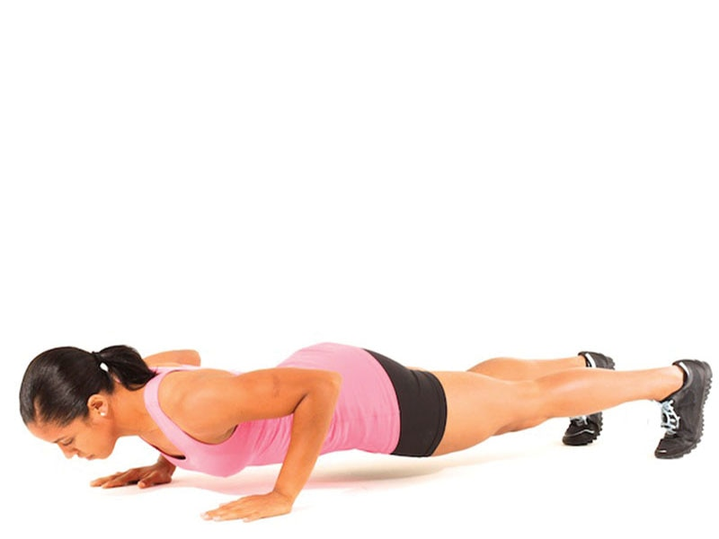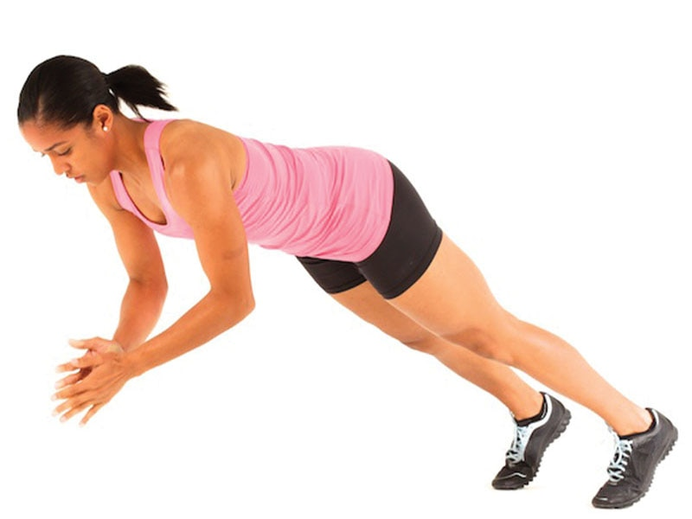

SAFETY

Avoid this exercise if the client experiences hand or wrist pain.